E-Commerce Fraud

## Query 1: Fraud Rate by Payment Method

Business Question: Which payment method carries the highest fraud risk?

Query:
SELECT Payment_Method,
COUNT(*) AS total_transactions,
SUM(Is_Fraudulent) AS fraud_count,
ROUND(SUM(Is_Fraudulent)*100.0/COUNT(*), 2) AS fraud_rate_pct
FROM transactions
GROUP BY Payment_Method
ORDER BY fraud_rate_pct DESC;

Result:

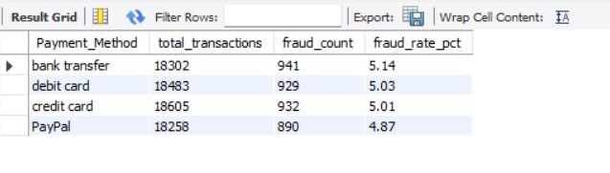

Insight: Fraud rate is nearly identical across all four payment methods (ranging only 4.87%–5.14%, all close to the overall average of 5.01%). This suggests payment method alone is not a strong fraud predictor in this dataset — fraud appears to be evenly distributed rather than concentrated in one payment channel.

Recommendation: Since payment method isn't a differentiating risk factor, fraud prevention efforts should focus on other signals (order value, address mismatch, timing) rather than restricting or adding friction to any specific payment method.

## Query 2: Fraud Rate by Product Category

Business Question: Which product category carries the highest fraud risk?

Query:
SELECT Product_Category,
COUNT(*) AS total_transactions,
SUM(Is_Fraudulent) AS fraud_count,
ROUND(SUM(Is_Fraudulent)*100.0/COUNT(*), 2) AS fraud_rate_pct
FROM transactions
GROUP BY Product_Category
ORDER BY fraud_rate_pct DESC;

Result:

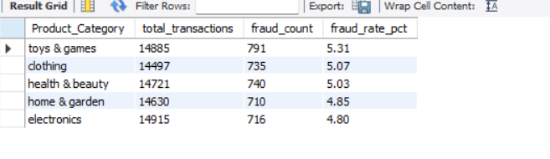

Insight: Similar to payment method, fraud rate is fairly uniform across product categories (4.80%–5.31%), with no single category standing out as significantly higher risk. Toys & Games has the highest rate but the gap is narrow — likely not statistically meaningful on its own.

Recommendation: Category-based fraud rules alone won't be effective here; fraud detection should rely on transaction-level signals (order value, address mismatch, account age) rather than category-based flags.

## Query 3: Fraud Rate by Account Age

Business Question: Are newer accounts more likely to commit fraud?

Query:
SELECT
CASE
WHEN Account_Age_Days <= 30 THEN '0-30 days (New)'
WHEN Account_Age_Days <= 90 THEN '31-90 days'
WHEN Account_Age_Days <= 180 THEN '91-180 days'
WHEN Account_Age_Days <= 365 THEN '181-365 days'
ELSE '365+ days (Old)'
END AS account_age_bucket,
COUNT(*) AS total_transactions,
SUM(Is_Fraudulent) AS fraud_count,
ROUND(SUM(Is_Fraudulent)*100.0/COUNT(*), 2) AS fraud_rate_pct
FROM transactions
GROUP BY account_age_bucket
ORDER BY MIN(Account_Age_Days);

Result:
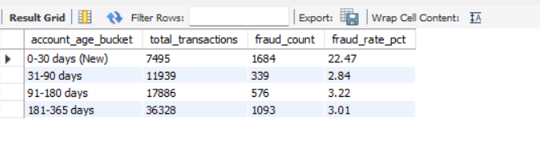

Insight: Account age is by far the strongest fraud signal found so far. Accounts under 30 days old have a fraud rate of 22.47% — roughly 4.5x the overall average (5.01%) and 7-8x higher than any older account bucket. Fraud rate drops sharply and stabilizes around 3% once an account is over 30 days old. This strongly suggests fraudsters predominantly use freshly created accounts, likely because throwaway accounts are easy to create and abandon.

Note: No accounts older than 365 days exist in this dataset — the 365+ bucket returned zero rows, confirming all 73,648 transactions are accounted for across the four buckets.

Recommendation: Apply stricter verification (e.g., manual review, delayed shipping, lower initial spend limits) for accounts under 30 days old, especially for high-value orders. This single rule alone could target the highest-concentration fraud segment without impacting the vast majority of legitimate, established customers.

## Query 4: Fraud Rate by Transaction Amount

Business Question: Are higher-value orders more likely to be fraudulent?

Query:
SELECT
CASE
WHEN Transaction_Amount <= 50 THEN '0-50'
WHEN Transaction_Amount <= 150 THEN '51-150'
WHEN Transaction_Amount <= 300 THEN '151-300'
WHEN Transaction_Amount <= 500 THEN '301-500'
ELSE '500+'
END AS amount_bucket,
COUNT(*) AS total_transactions,
SUM(Is_Fraudulent) AS fraud_count,
ROUND(SUM(Is_Fraudulent)*100.0/COUNT(*), 2) AS fraud_rate_pct,
ROUND(AVG(Transaction_Amount), 2) AS avg_amount
FROM transactions
GROUP BY amount_bucket
ORDER BY MIN(Transaction_Amount);

Result:
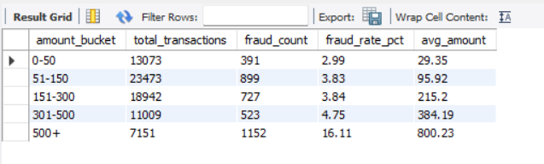

Insight: Fraud rate shows a clear upward trend with transaction value — rising from 2.99% for small orders (₹0-50) to 16.11% for high-value orders (₹500+), roughly 5.4x higher than the smallest bucket. The jump is especially sharp above ₹500, suggesting fraudsters target high-value orders for maximum payout per attempt, consistent with typical fraud economics.

Recommendation: Flag all orders above ₹500 for additional verification (e.g., OTP confirmation, manual review), especially when combined with a new account (under 30 days) — the intersection of these two risk factors likely represents the highest-risk segment in the dataset.

## Query 5: Combined Risk Segment (New Account + High-Value Order)

Business Question: What is the fraud rate when both risk factors (new account + high order value) occur together?

Query:

SELECT
CASE
WHEN Account_Age_Days <= 30 AND Transaction_Amount > 500 THEN 'New Account + High Value (High Risk)'
ELSE 'All Other Transactions'
END AS risk_segment,
COUNT(*) AS total_transactions,
SUM(Is_Fraudulent) AS fraud_count,
ROUND(SUM(Is_Fraudulent)*100.0/COUNT(*), 2) AS fraud_rate_pct
FROM transactions
GROUP BY risk_segment;

Result:
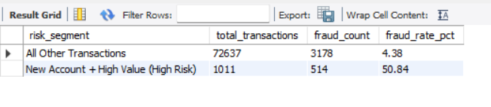

Insight: This is the single strongest finding in the analysis. Orders that are both from an account under 30 days old AND valued above ₹500 have a fraud rate of 50.84% — nearly 12x higher than the rest of the dataset (4.38%). This segment represents only 1.37% of total transactions (1,011 out of 73,648) but accounts for 13.9% of all fraud cases (514 out of 3,692) — a highly concentrated, high-precision risk signal.

Recommendation: Implement a mandatory manual review or additional verification (OTP, delayed shipping, ID confirmation) for any transaction where the account is under 30 days old AND the order value exceeds ₹500. This single rule targets a segment where a transaction is more likely to be fraudulent than legitimate, while affecting less than 1.5% of total order volume — minimizing friction for genuine customers.

## Query 6: Fraud Rate by Hour of Day

Business Question: Does fraud concentrate at specific hours (e.g., late night)?

Query:
SELECT
HOUR(Transaction_Date_Clean) AS transaction_hour,
COUNT(*) AS total_transactions,
SUM(Is_Fraudulent) AS fraud_count,
ROUND(SUM(Is_Fraudulent)*100.0/COUNT(*), 2) AS fraud_rate_pct
FROM transactions
GROUP BY HOUR(Transaction_Date_Clean)
ORDER BY transaction_hour;

Result: Fraud rate stays fairly flat across all 24 hours, ranging from 4.18% (11 AM) to 6.15% (1 PM) — no meaningful late-night or off-hours spike.

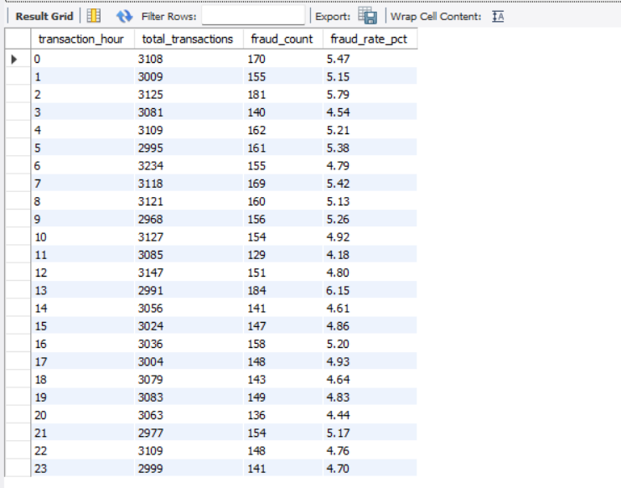

Insight: Unlike account age and transaction amount, time-of-day shows no strong fraud signal — fraud is evenly distributed throughout the day. This suggests fraudulent activity here isn't tied to reduced monitoring during odd hours, but rather to account/order characteristics (age, value) regardless of when the transaction occurs.

Recommendation: Time-based rules (e.g., flagging late-night orders) would not be effective for this dataset; fraud prevention resources are better spent on account-age and order-value based rules (see Query 3 and Query 5).

## Query 7: Fraud Rate by Device Used

Business Question: Is any device type associated with higher fraud rates?

Query:
SELECT Device_Used,
COUNT(*) AS total_transactions,
SUM(Is_Fraudulent) AS fraud_count,
ROUND(SUM(Is_Fraudulent)*100.0/COUNT(*), 2) AS fraud_rate_pct
FROM transactions
GROUP BY Device_Used
ORDER BY fraud_rate_pct DESC;

Result:
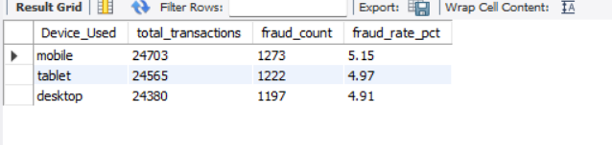

Insight: Device type shows no meaningful fraud differentiation (4.91%–5.15%, all near the overall average). Fraud is not concentrated on any particular device or platform.

Recommendation: Device type is not a useful fraud signal on its own and should not be used as a standalone flagging criterion.

